Assignment #1, Review, for Computer Science 1160
Algorithm, Procedural Abstraction
Newton’s Method to find the square root of a non-negative number.

Let α≥0 be a number. It’s square root 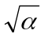 can be computed by Newton’s Method. That is take a rough estimate at an original value, say, 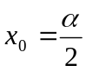. Then the following sequence gets as close to as you wish
Sir Isaac Newton 1643-1727
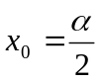, 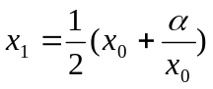,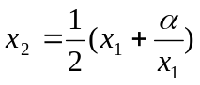,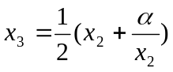,
- As comment in your source code, write an Algorithm to implement Newton’s Method. Note that you will need a small constant, call it EPSILON, to check if consecutive values of the iteration are close enough to each other determined by EPSILON. This determines when iteration stops.
- Write a square root function, call it mySqrt, that implements Newton’s Method. The prototype should be
double mySqrt(double a, double precision);
- Write a C++ program that uses mySqrt and solves the quadratic equation
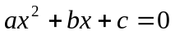, with solutions 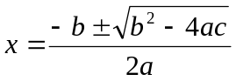, provided 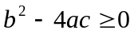
Note that cannot equal 0, otherwise, the equation is not quadratic.
- Your input is provided in a txt file. Each line of the file contains 4 doubles: EPSILON, a, b, c, respectively.
- Put a Counter in the mySqrt function and each time that the function is called it should print to the Console the input values, the square root and the number of iterations that it performed to compute the square root.
- Print the two roots of the quadratic equation to the Console, if they exist. Otherwise print an appropriate message.
Submit with Blackboard CE:
- A document with the output of your program. In that document, and for each case, add the expected result as it would be calculated by hand (using a calculator).
- The source code (e.g. newton.cpp). Make sure your Algorithm is included. Also, add enough comments to make your program understandable
- The executable, newton.exe. The marker must be able to run your program and see the output.
- Do not change the name or content of the Test File. Otherwise, the marker may not be able to run your program.

